
Community Information 3/1/25 – 3/31/25
- On 3/7/25, officers responded to the 2100 block of Old Snow Hill Road , in reference to a suspicious person. As a result of this incident, an adult male was arrested on an outstanding arrest warrant. The arrestee was transported to the Pocomoke City Police Department for processing. The arrestee later had an initial appearance hearing with a District Court Commissioner. At the conclusion of the hearing, he was released on his own personal recognizance.
- On 3/8/25 as a result of a traffic stop, an adult female, was charged with driving on a suspended drivers’ license. She was issued several traffic citations and released at the scene. A licensed driver took possession of the vehicle.
- On 3/8/25, officers responded to the 400 block of Laurel Street, in reference to attempting to locate a wanted subject. As a result of this incident, an adult male was arrested on an outstanding arrest warrant. The arrestee was transported to the Pocomoke City Police Department for processing. The arrestee later had an initial appearance hearing with a District Court Commissioner. At the conclusion of the hearing, he was released on his own personal recognizance.
- As a result of an on-going theft investigation, on 3/9/25, an adult female was charged with theft scheme. She was served with a criminal summons and notice of a court date. On she received a copy of all documentation she was released at the scene.
- On 3/10/25 as a result of a traffic stop, an adult male, was charged with driving on a suspended drivers’ license. He was issued several traffic citations and released at the scene. A licensed driver took possession of the vehicle.
- On 3/11/25 as a result of a traffic stop, an adult female, was charged with driving on an out of state suspended drivers’ license. She was issued several traffic citations and released at the scene. A licensed driver took possession of the vehicle.
- On 3/11/25, officers responded to the 1500 block of Market Street, in reference to a wanted subject. As a result of this incident, an adult male was arrested on an outstanding arrest warrant. The arrestee was processed at the Pocomoke City Police Department. The arrestee later had an initial appearance hearing with a District Court Commissioner. At the conclusion of the hearing, he was released on his own personal recognizance.
- On 3/12/25 as a result of a traffic stop, an adult male, was charged with driving on a suspended drivers’ license. He was issued several traffic citations and released at the scene. A licensed driver took possession of the vehicle.
- On 3/12/25, officers responded to the 600 block of Lynnhaven Drive, in reference to executing an arrest warrant. As a result of this incident, an adult male was arrested on an outstanding arrest warrant. The arrestee was transported to the Pocomoke City Police Department for processing. The arrestee later had an initial appearance hearing with a District Court Commissioner. At the conclusion of the hearing, he was ordered to be held on no bond. The arrestee was later transported to the Worcester County Jail.
- On 3/12/25, officers responded to the 2100 block of Old Snow Hill Road , in reference to a trespassing complaint. As a result of this incident, an adult female was arrested for trespassing. The arrestee was transported to the Pocomoke City Police Department for processing. The arrestee was later released on a criminal citation.
- On 3/14/25, officers responded to the 2100 block of Old Snow Hill Road , in reference to a theft. As a result of this incident, an adult male was arrested for theft. The arrestee was transported to the Pocomoke City Police Department for processing. The arrestee was released on a criminal citation.
- On 3/20/25, an adult was extradited and arrested for an outstanding arrest warrant that included Burglary 2nd degree. The arrestee was transported to the Pocomoke City Police Department for processing. The arrestee was seen by a District Court Commissioner and ordered to be held on no bond. The arrestee was later transported to the Worcester County Jail.
- On 3/21/25, officers responded to the area of Seventh Street at Cedar Street in reference to shots fired. Dispatch obtained a description of the adult male and provided the description to responding officers. Officers were able to locate an adult male in the area matching the description. The suspect matching the description then fled on foot from the police. A short while later, police were able to apprehend the fleeing suspect, who was in possession of a loaded .380 Smith and Wesson Semi-auto handgun. He was placed under arrest and for multiple charges to include reckless endangerment, handgun on person, and failing to obey a lawful order. The arrestee was transported to the Pocomoke City Police Department for processing. The arrestee was later seen by a District Court Commissioner and ordered to be held on no bond. The arrestee was later transported to the Worcester County Jail. The arrestee resides in the Princess Anne area.
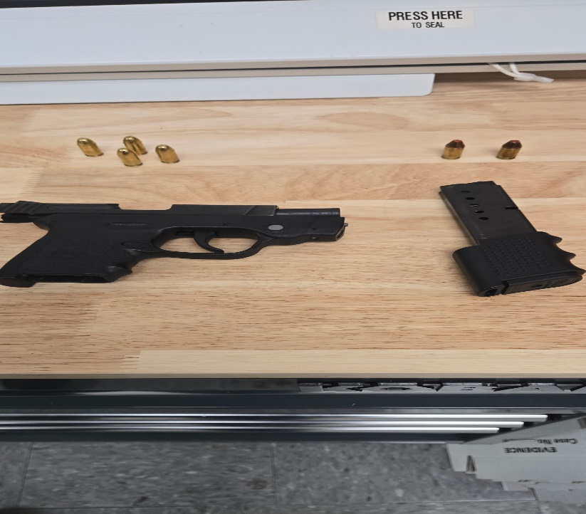
- On 3/24/25, as a result of an ongoing investigation, an adult female was charged with assault second degree, reckless endangerment and child abuse 2nd degree. An application for charges was completed, and a criminal summons was issued. The female was served copies of the criminal summons and released on scene.
- On 3/26/25, officers responded to the 2100 block of Old Snow Hill Road in reference to a theft. As a result of this incident, an adult male was arrested for theft. The arrestee was transported to the Pocomoke City Police Department for processing. The arrestee was seen by a District Court Commissioner and ordered to be held on a $450 bond. The arrestee was later transported to the Worcester County Jail.

